
Agenda
What is Spark
Spark Architecture
Spark Benefits
Lazy Evolution
Jobs,Stages and Tasks
Databricks Free account
Spark Language Options
PySpark Coding – The Real OG

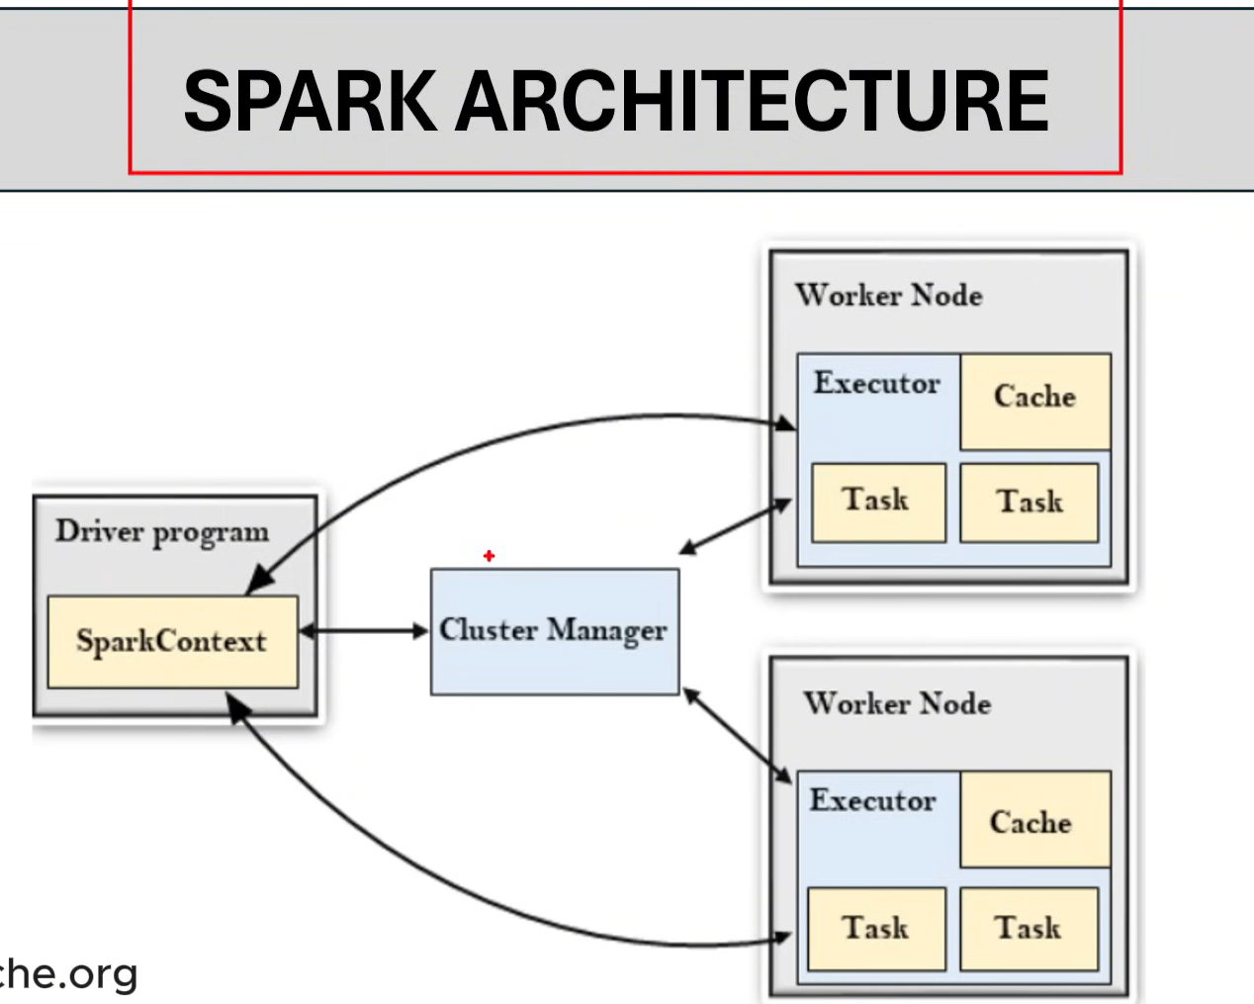
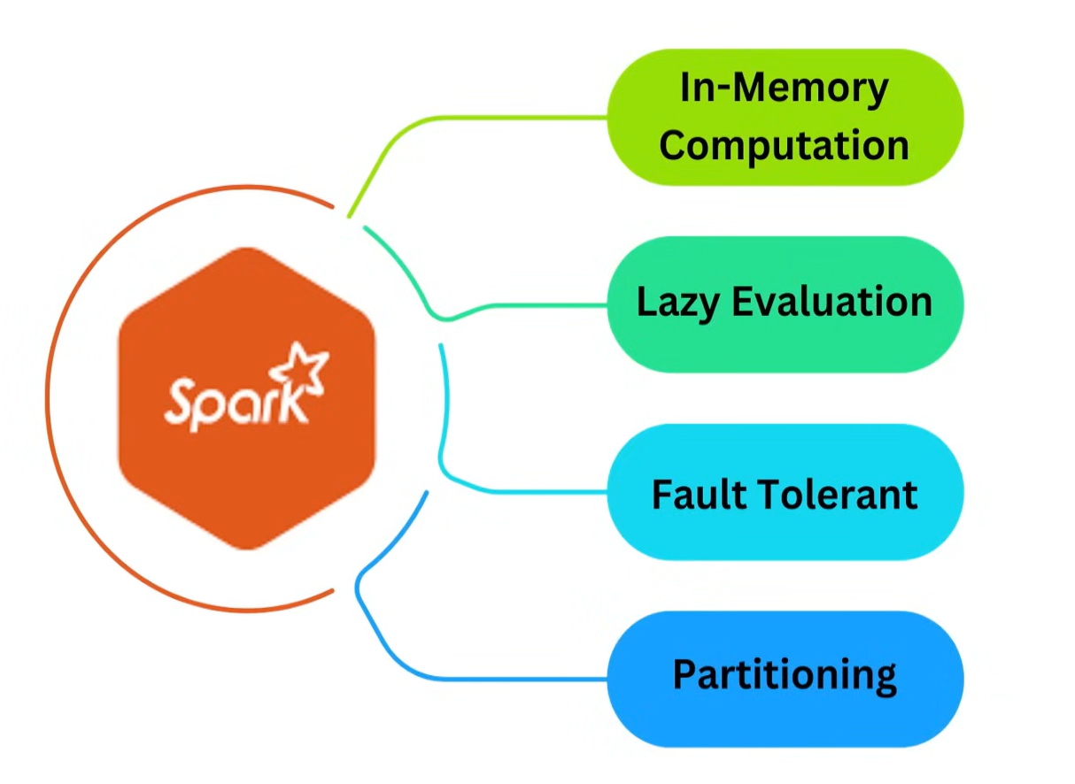
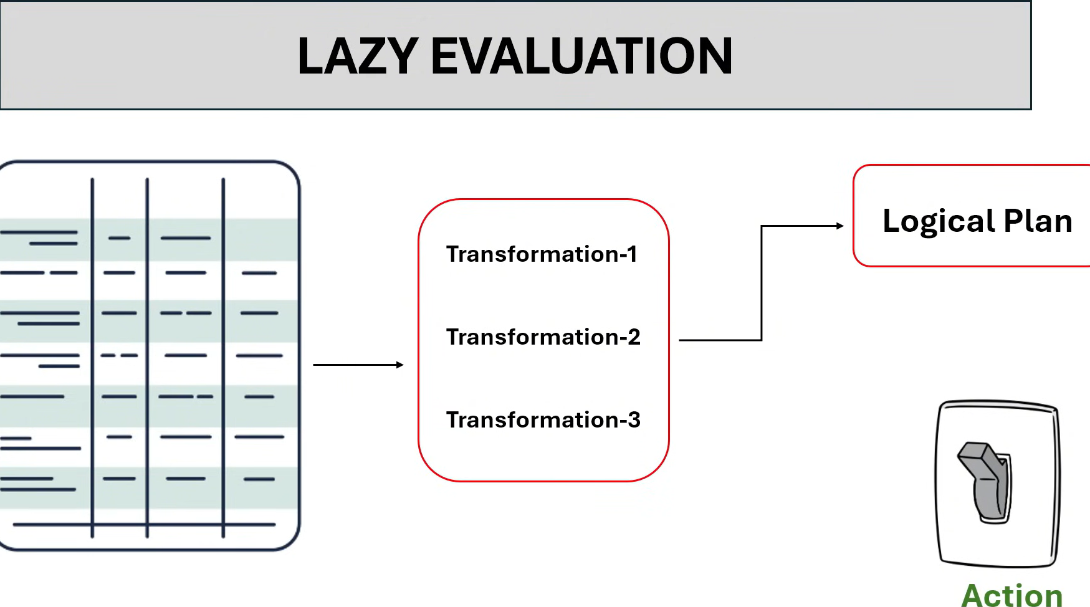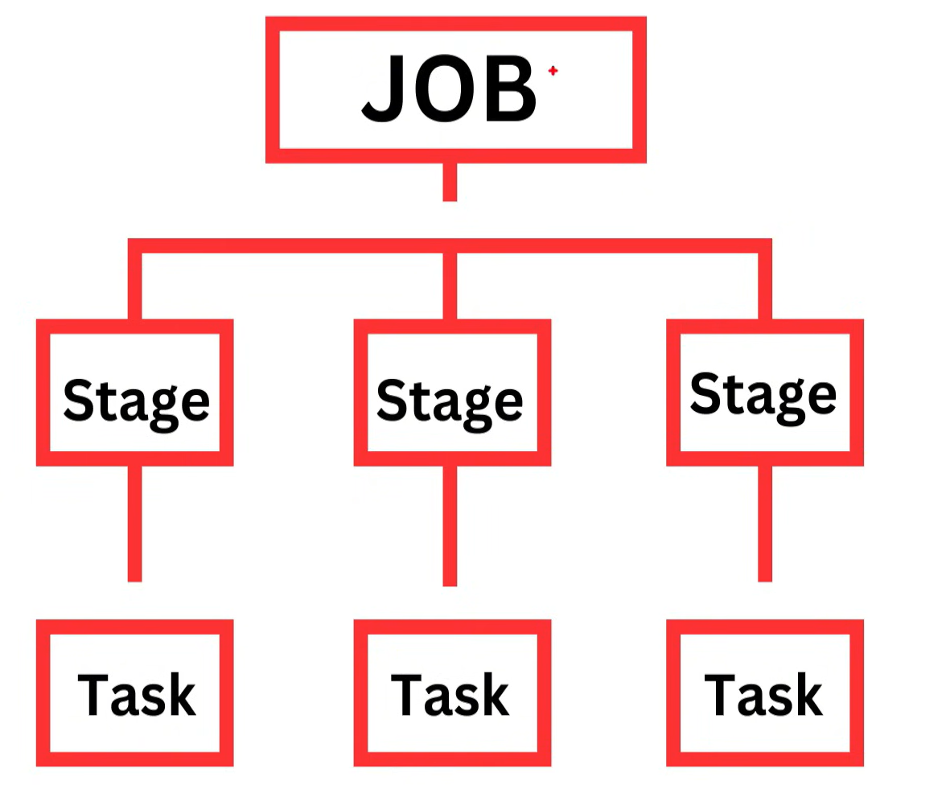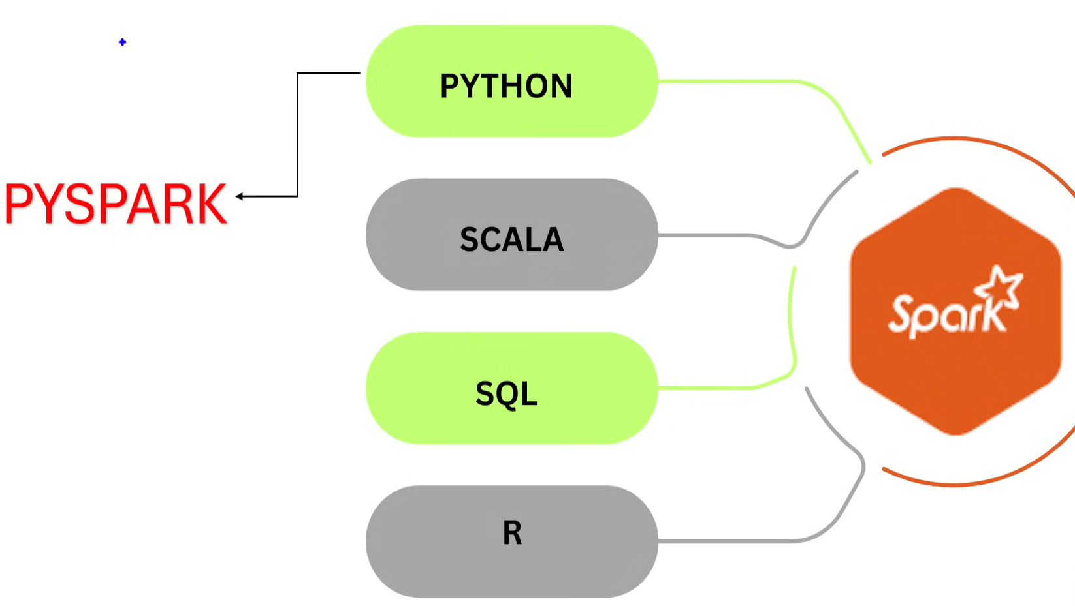

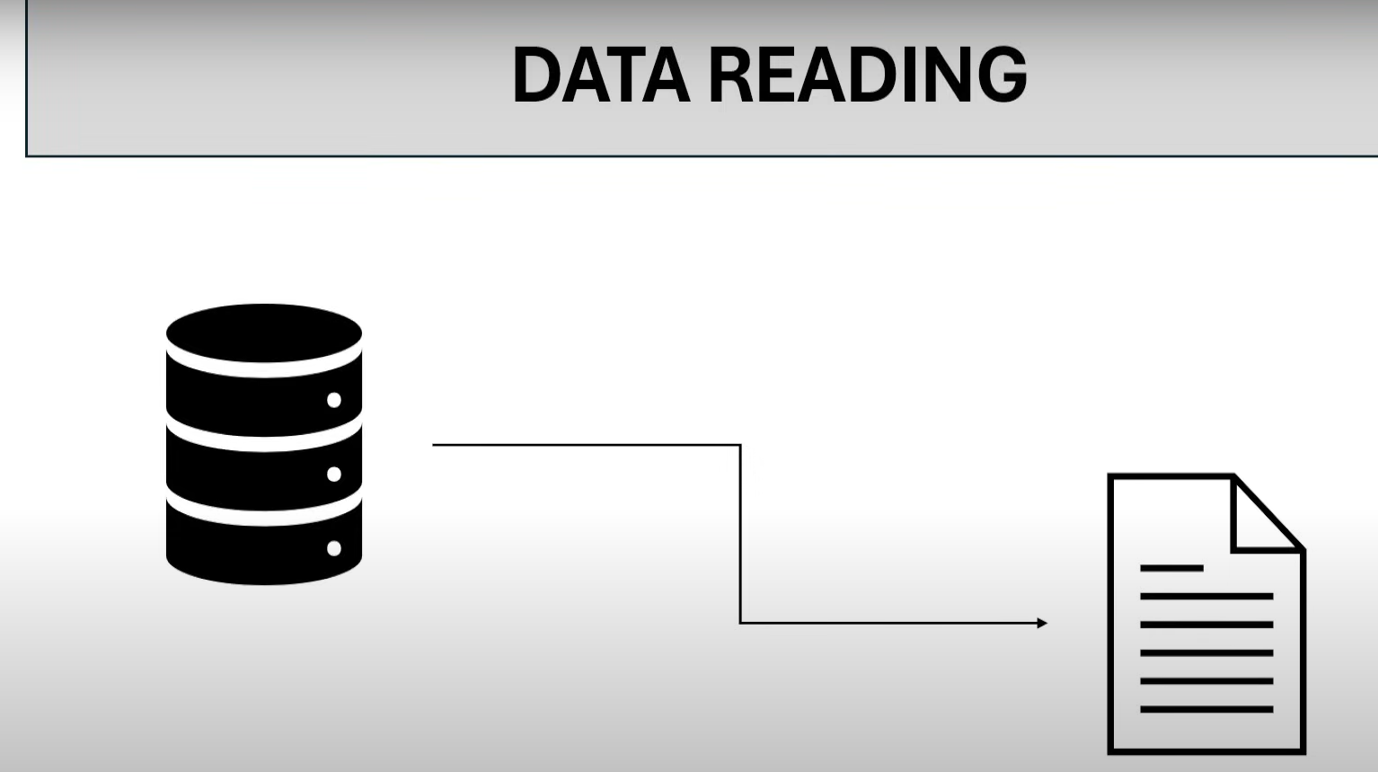
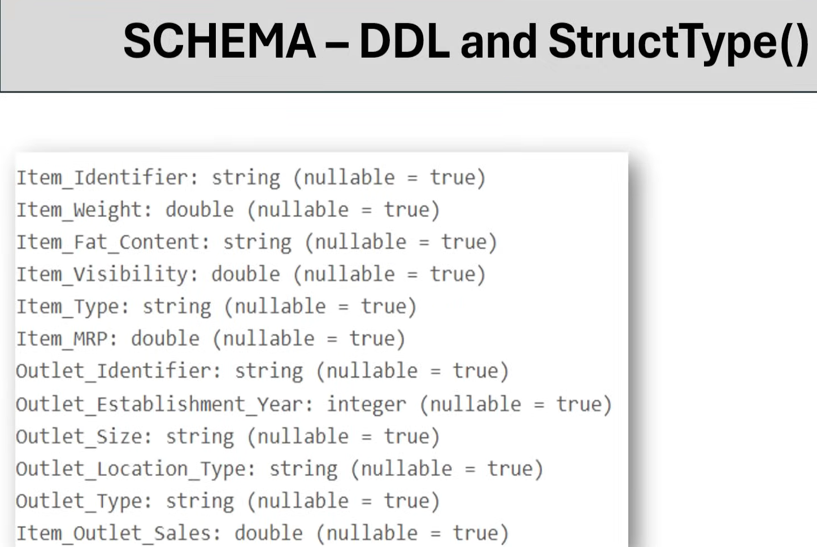
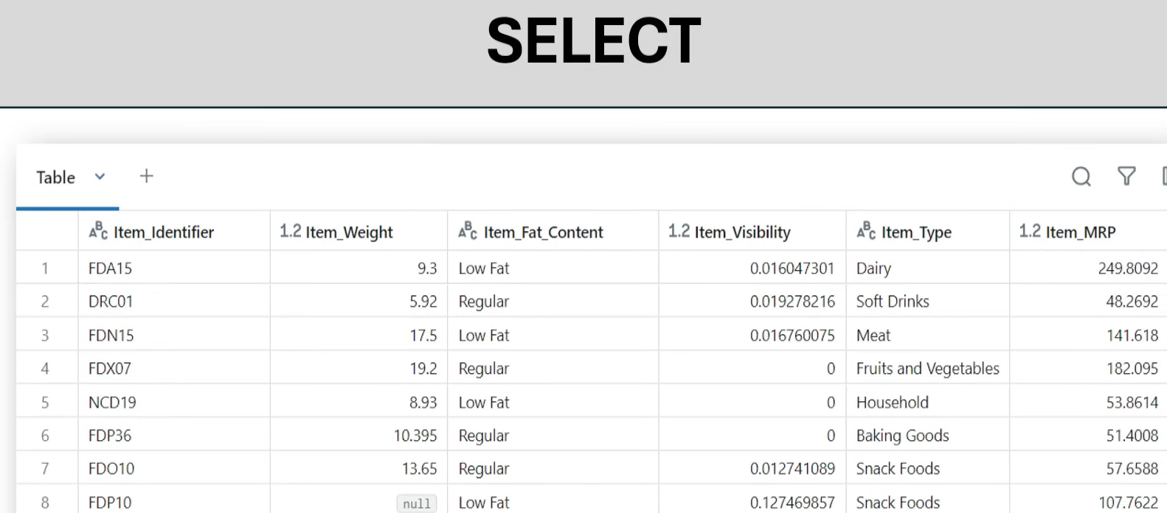
After this 1)Select
2)Col
3)Alias
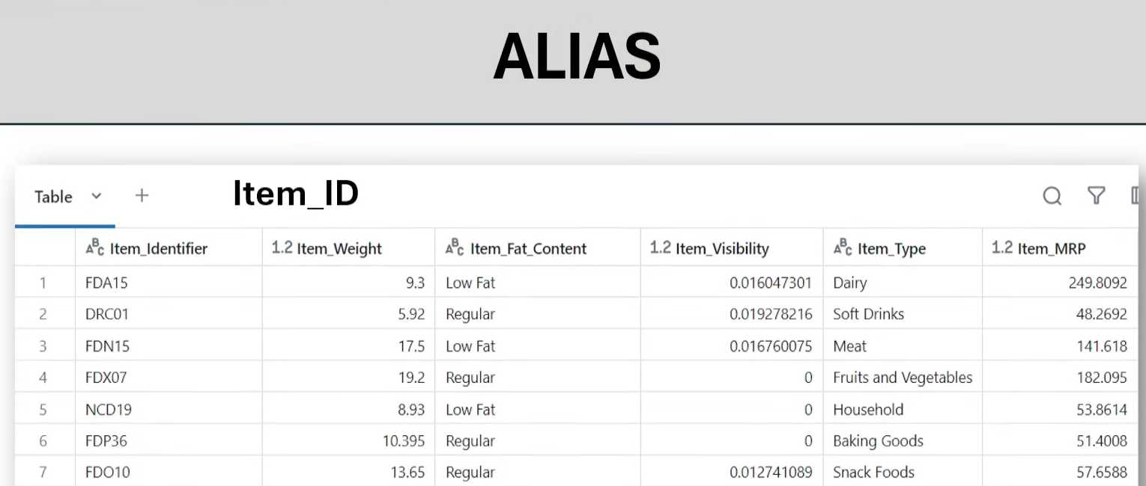
Df.select(col(‘Item_Identifier’).alias(“Item_id”)).display()

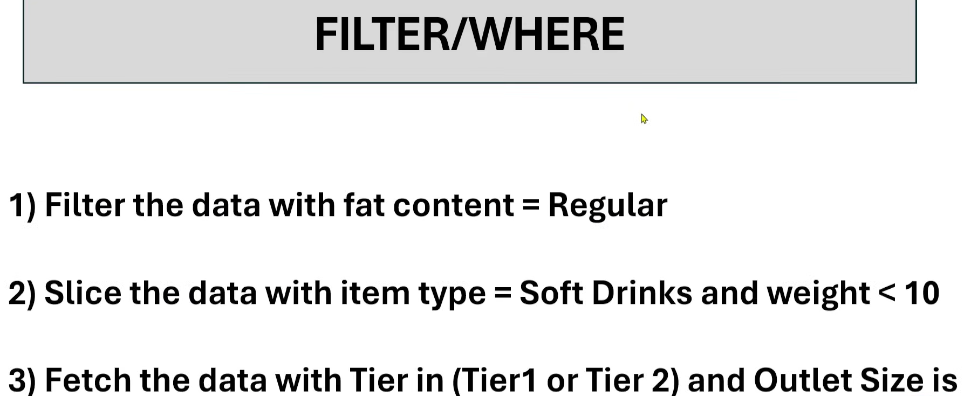


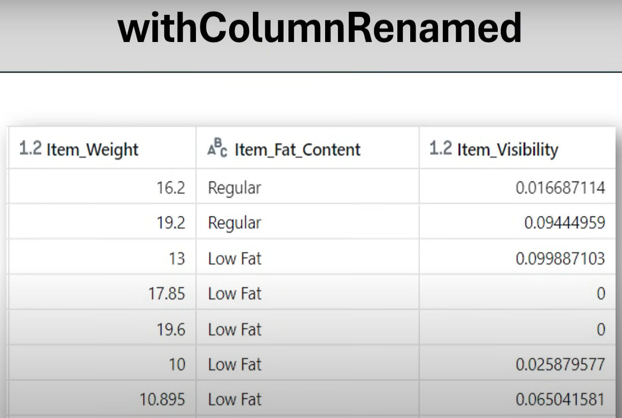

Df.witcolumnrenamed(‘Item_weight’,’Item_wt’).display()
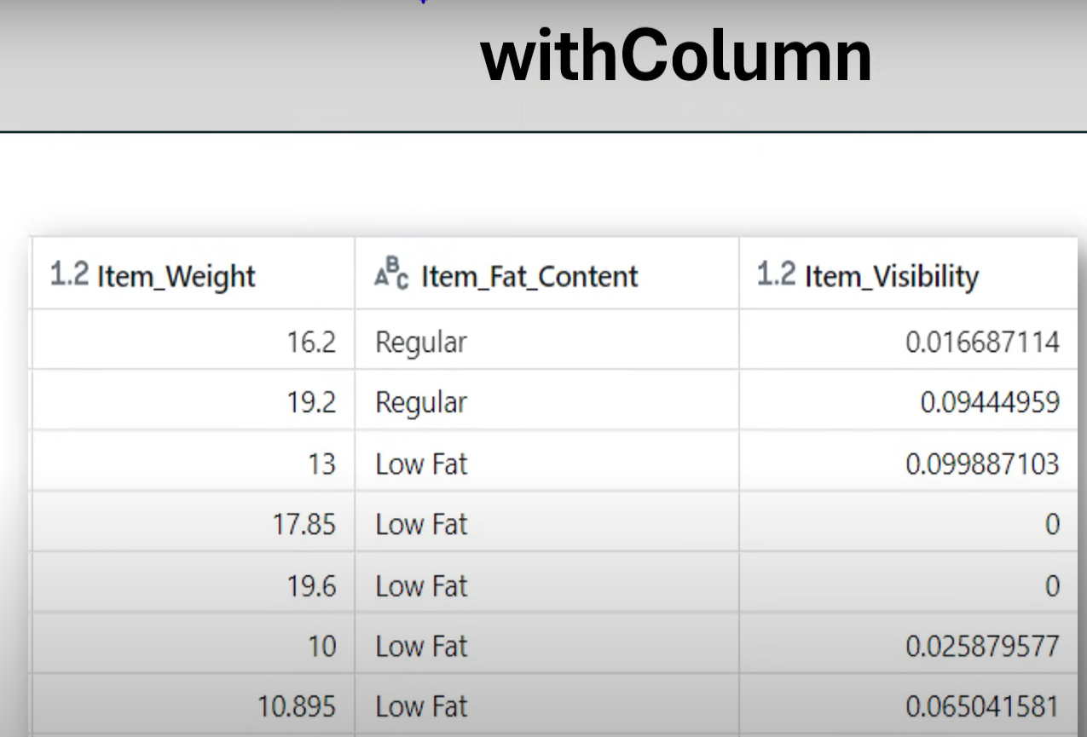
Df.withcolumn(‘flag’,lit(‘new’)).display();
Df.withcolumn(‘multiply’,col(‘item_weight’)*col(‘item_mrp’)).display();
Df.withcolumn(‘item_fat_content’,regexp_replace(col(‘Item_fat_content’,”Regular”,”Reg”))).display();
withColumn: it is used to create a new column and used to update the existing values in the columns
Scenario1: create a new column with name flag and the constant value true
Scenario 2: multiply item_weight and item_mrp
Scenario 3: item fat content Low fat as LF and Regular as Reg

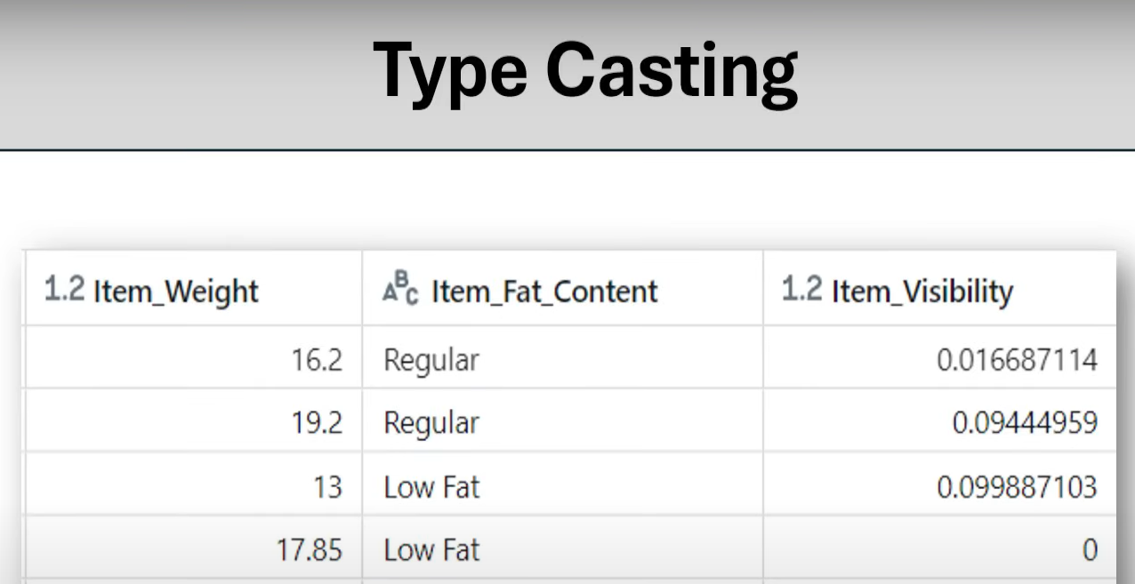
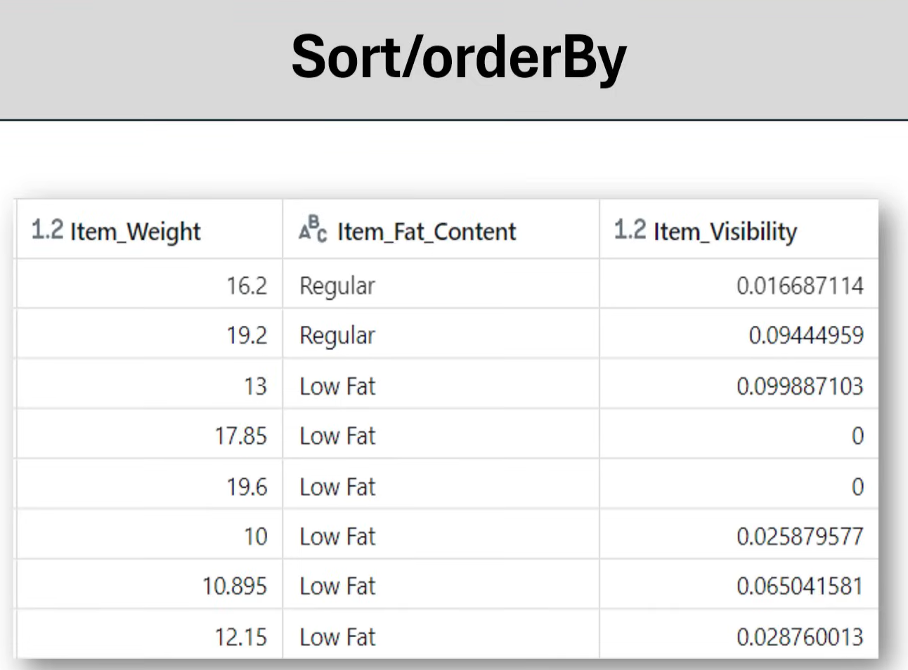
Scenario 1: Sort the column Item_weight in descending order
Scenario 2: Sort the column Item_visibility in ascending order
Scenario 3: Sort the columns Item_weight and Item_visibility in descending order
Scenario 4: Sort the columns Item_weight n descending order and Item_visibility in ascending order

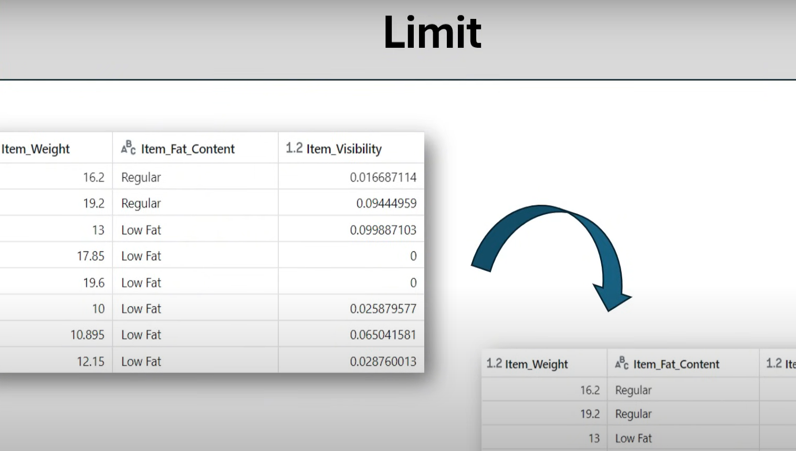

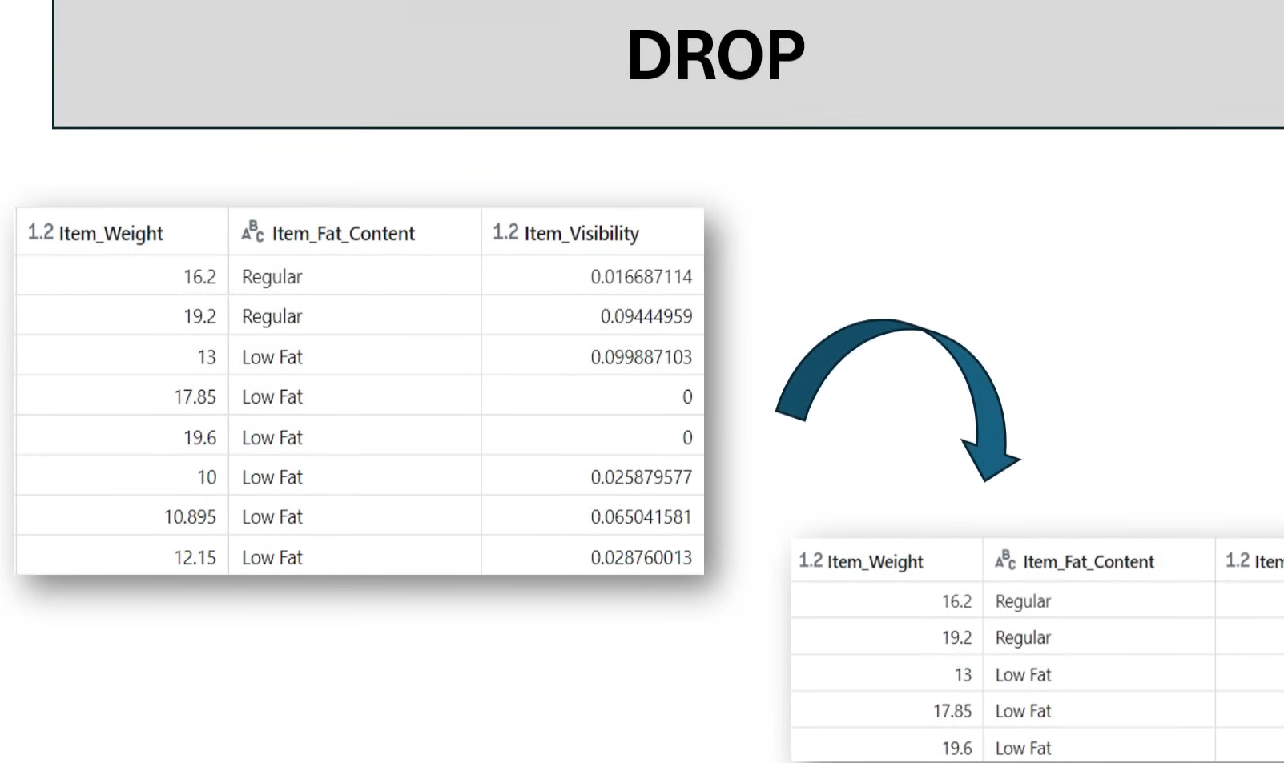

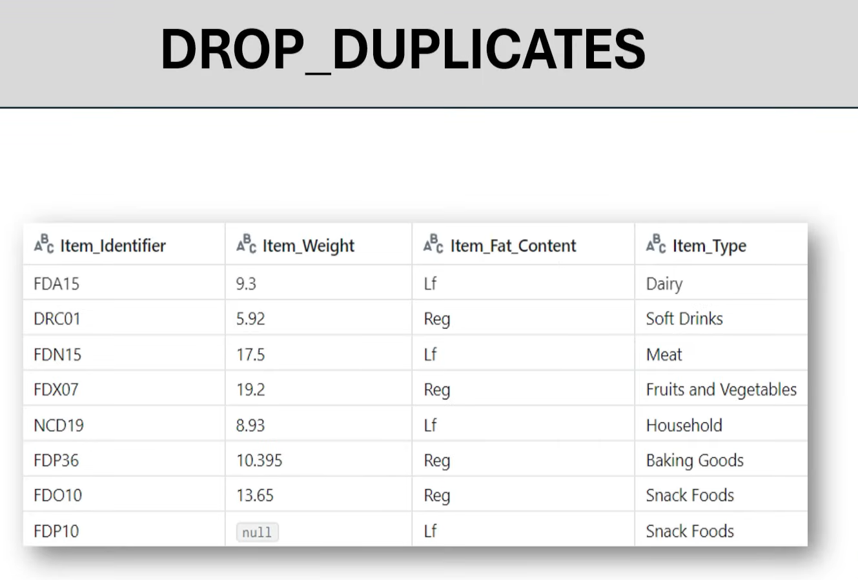
Scenario 1: drop duplicates
Scenario 2: drop duplicates for aprticular column Item type subset=
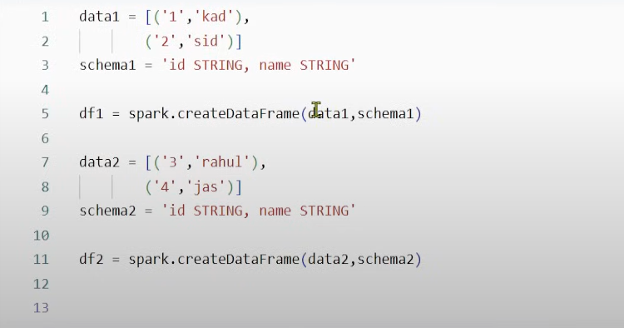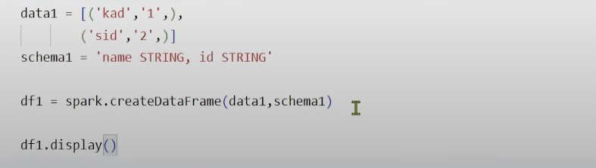
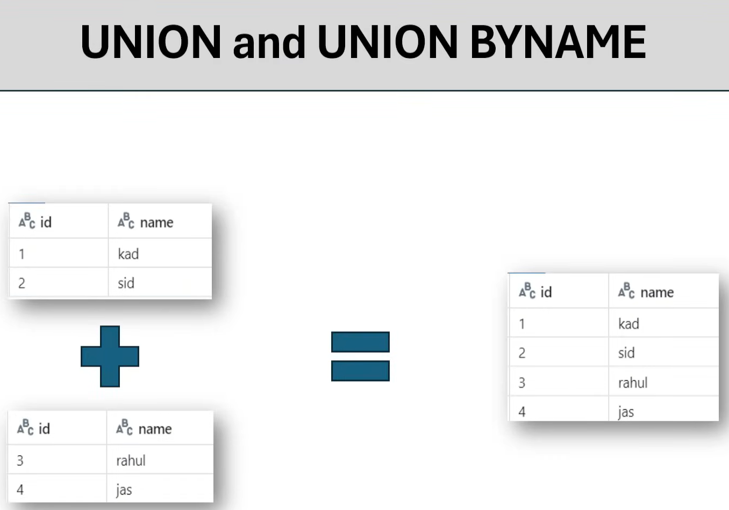
Df1.union(df2).display()
Df1.unionbyname(df2).display()

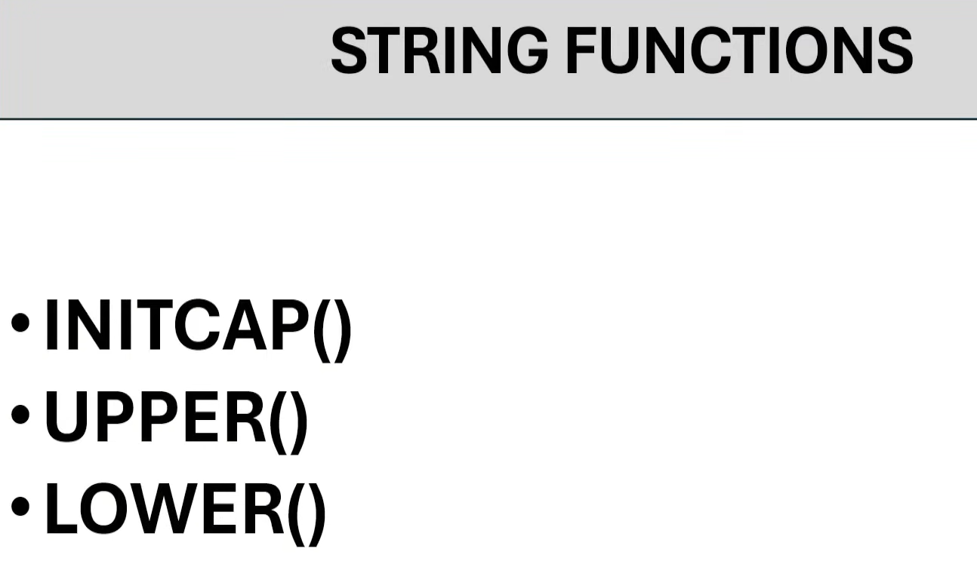
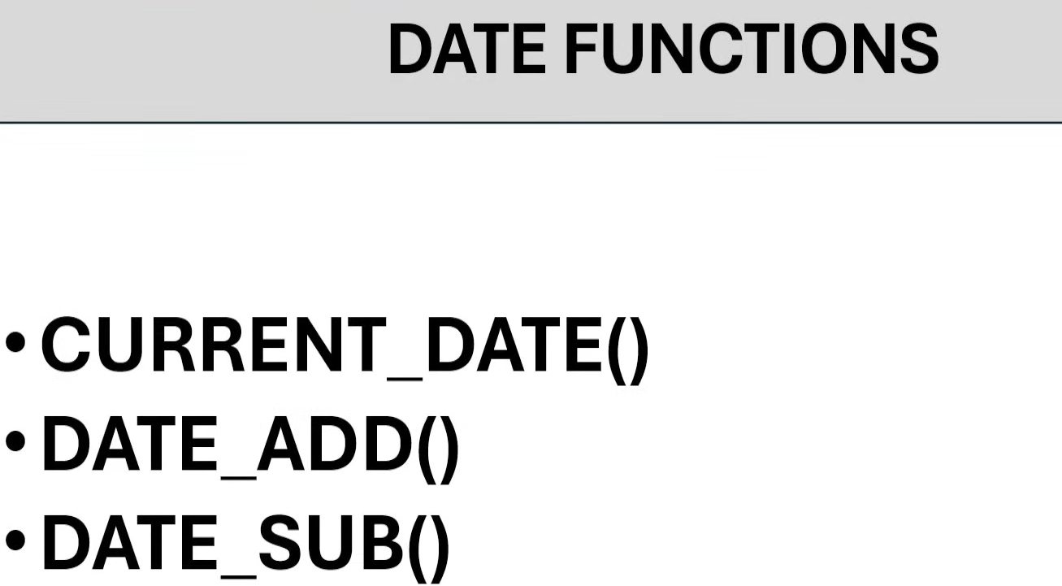
Df_curr = df.withcolumn(‘curr_date’,current_date())
Df_curr.display()
Df_add = df_curr.withcolumn(‘weef_after_date’,date_add(‘curr_date’,7))
Df_add.display()
Date_sub = Df_add.withcolumn(‘week_before_date’,date_sub(‘curr_date’,7))
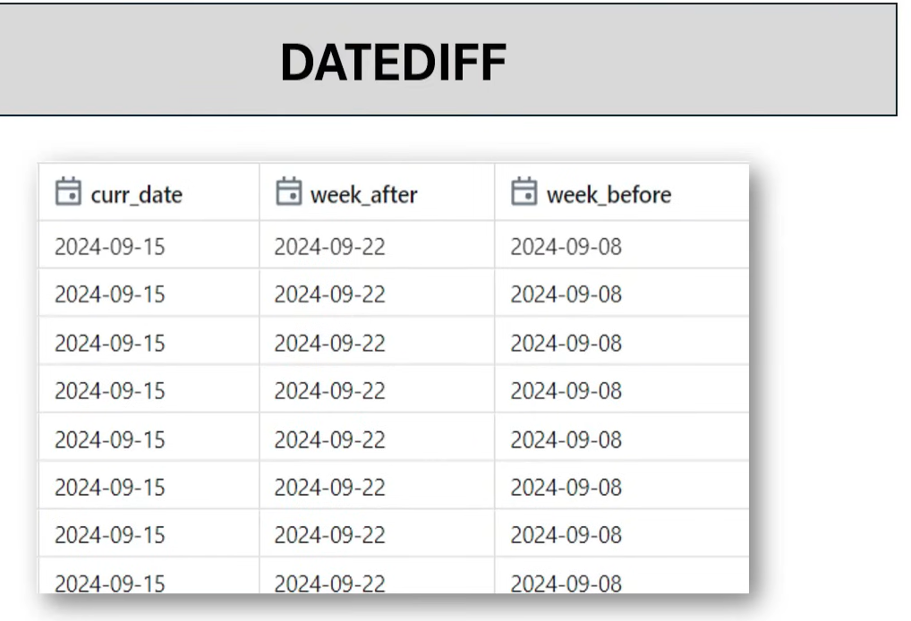

Date_diff=date_sub.withcolumn(‘datediff’,datediff(‘week_after’,curr_date))
Date_diff.display()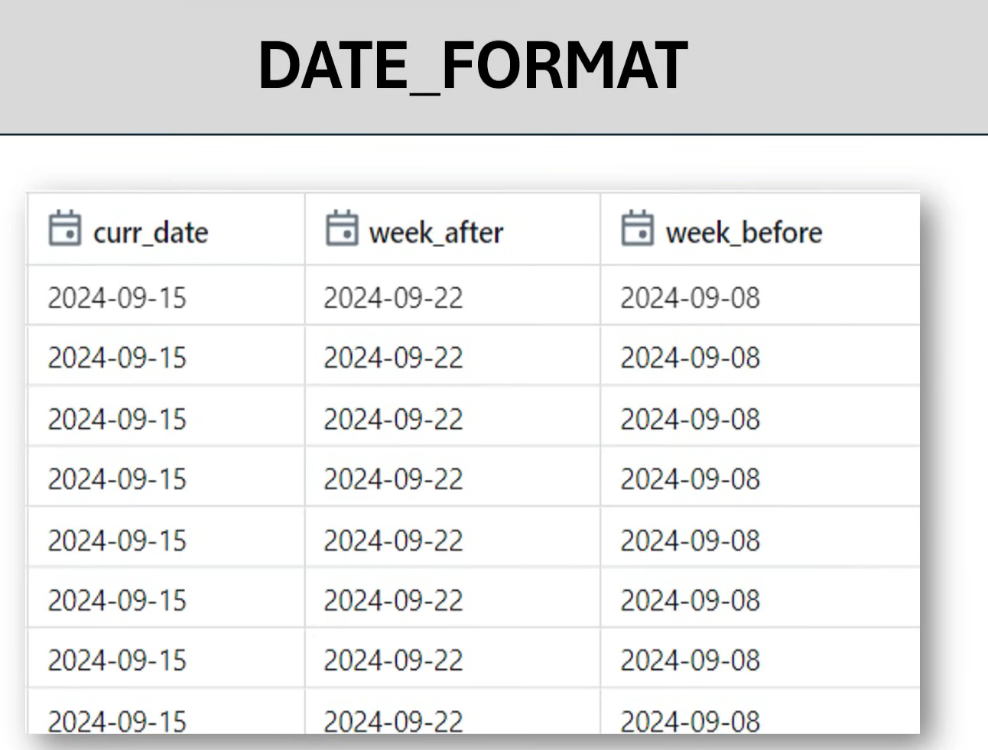
Date_diff.withcolumn(‘weekbefore’,date_format(‘week_before’,’dd-MM-yyyy’))
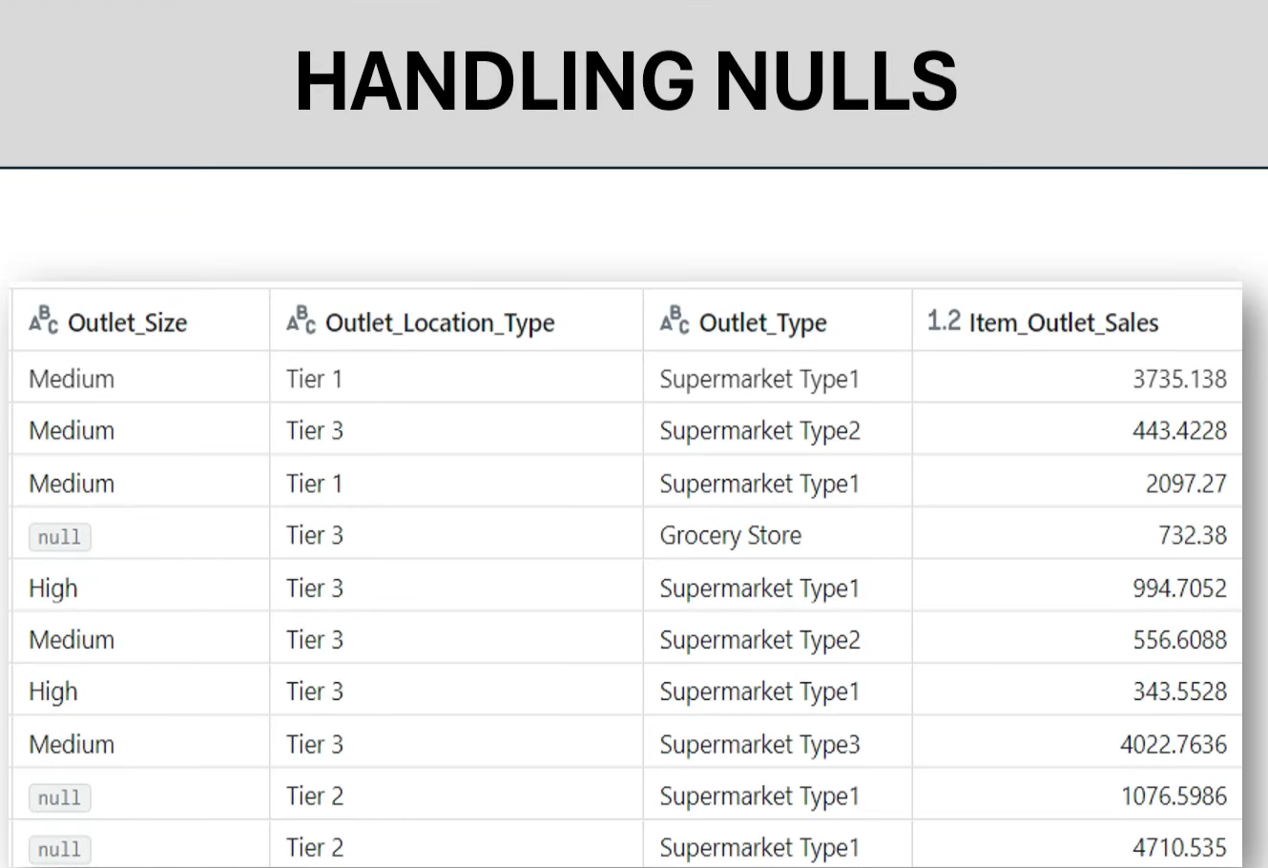
Df.dropna(‘all’).display()
Df.dropna(‘any’).display()
Df.dropna(subset=[‘Order_Size’]).display()
Df.fillna(‘notavailable’).display()
Df.fillna(‘notavailable’,subset=[‘Order_Size’]).display()
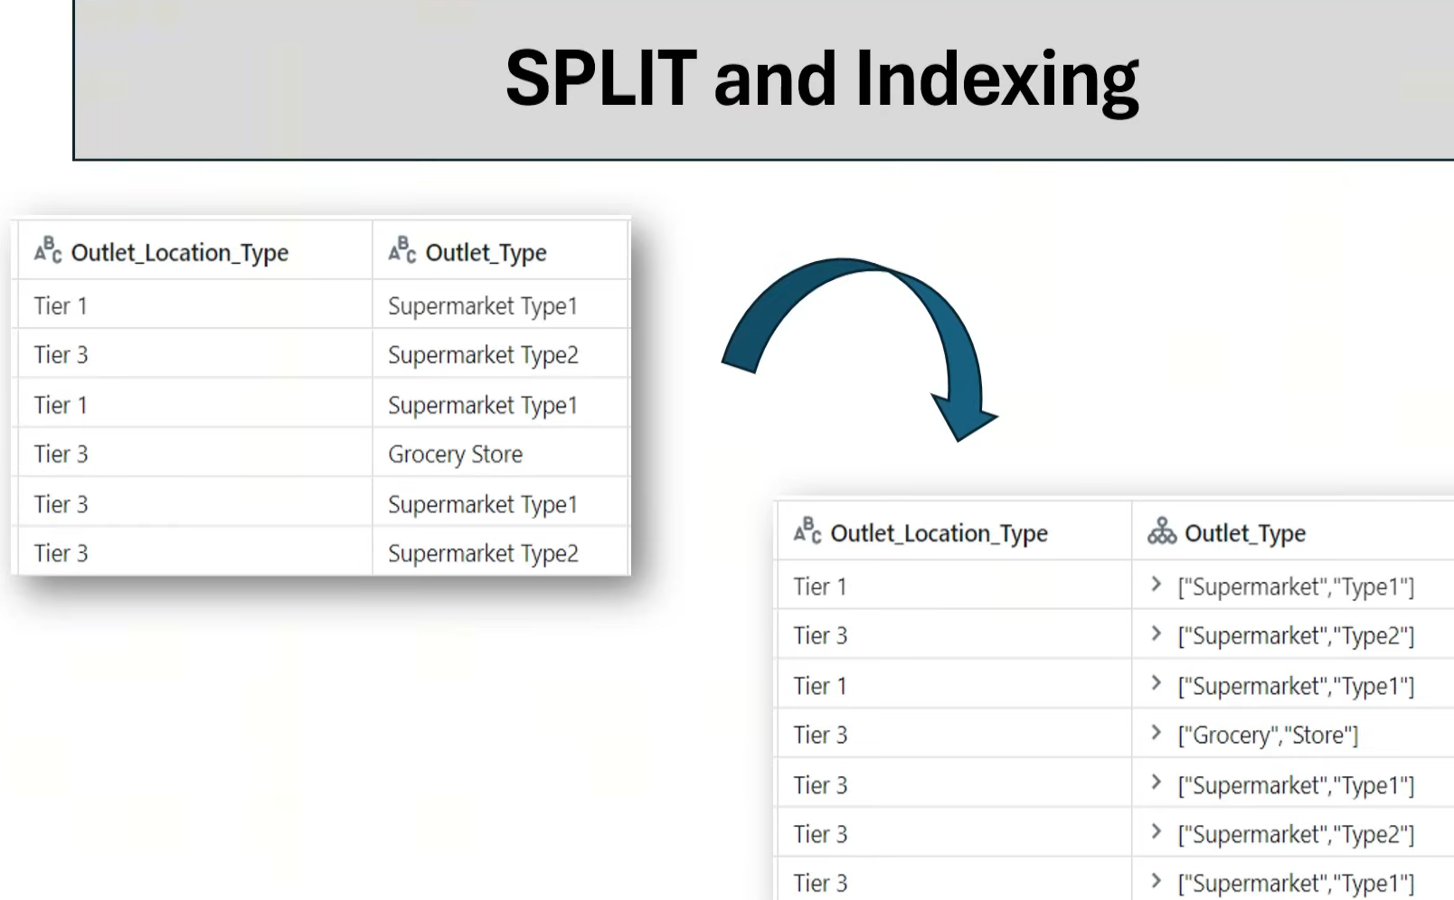
Df.withcolumn(‘Outlet_Type’,split(‘Outlet_Type’,’ ‘)).display()

Df.withcolumn(‘Outlet_Type’,split(‘Outlet_Type’,’ ‘)[1]).display()

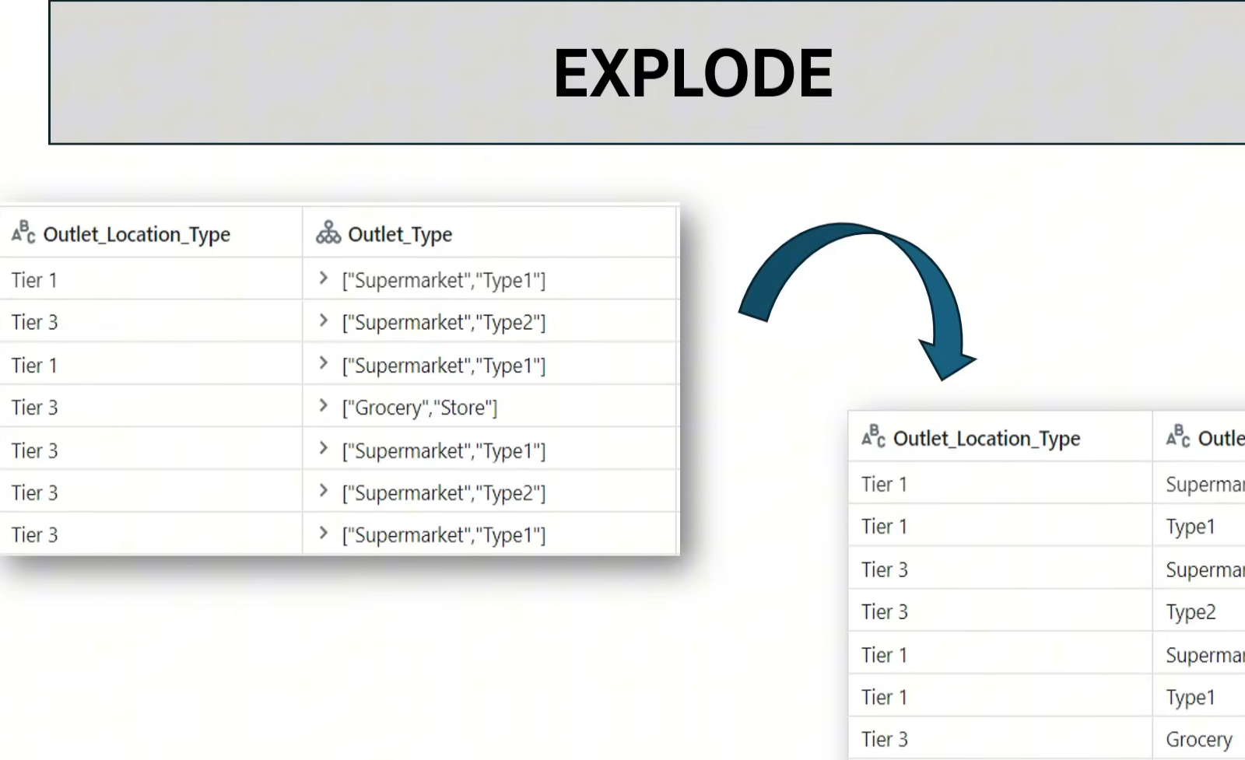
Df_exp = Df.withcolumn(‘Outlet_Type’,split(‘Outlet_Type’,’ ‘))
Df_exp.display()
Df_exp.withColumn(‘Outlet_Type’,explode(‘Outlet_Type’)).display()
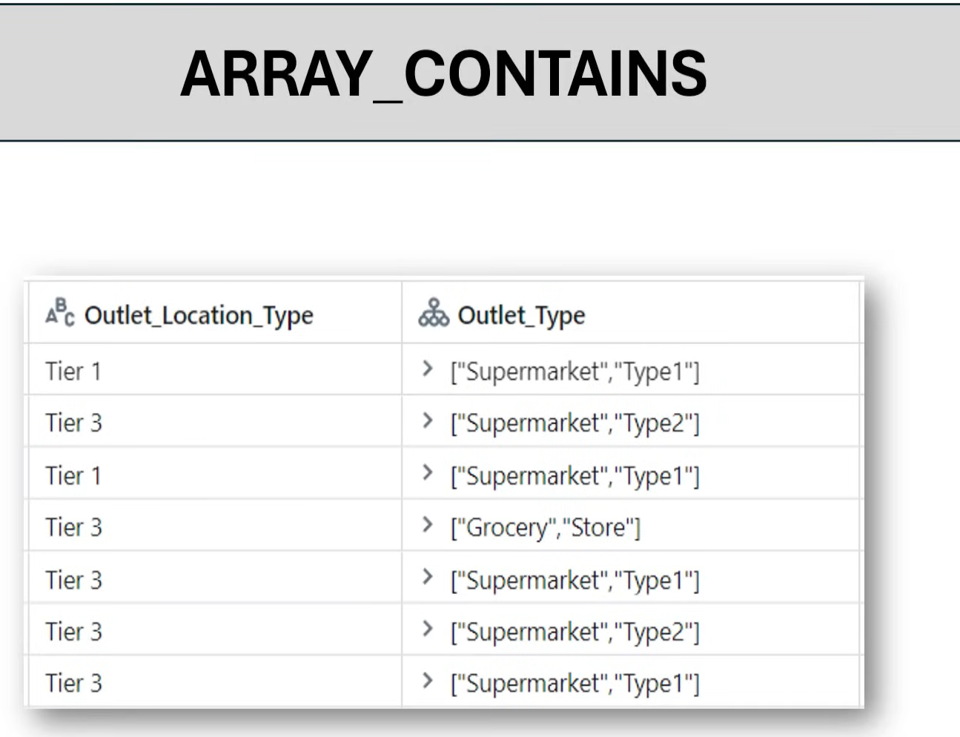
Df_exp.withcolumn(‘Type1_flag’,arraycontains(‘Outlet_Type’,’Type1’)).display()
Df.groupby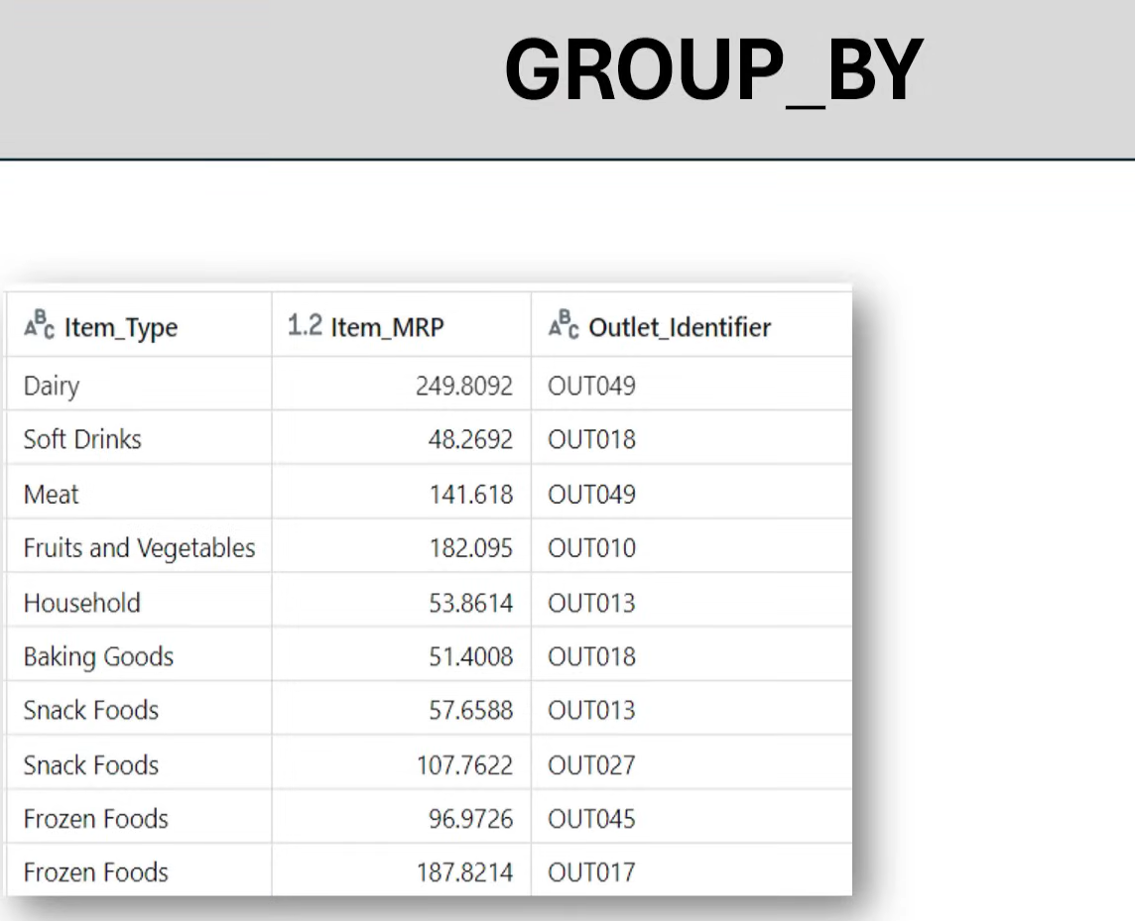
Df.groupby(‘Item_type’).agg(sum(‘Item_MRP’)).display()

Df.groupby(‘Item_type’).agg(avg(‘Item_MRP’)).display()
Df.groupby(‘Item_type’,’Outlet_size’).agg(avg(‘Item_MRP’).alias(‘Total MRP’)).display()
Df.groupby(‘Item_type’,’Outlet_size’).agg(sum(‘Item_MRP’,’avg(‘Item_MRP’).alias(‘Total MRP’)).display()
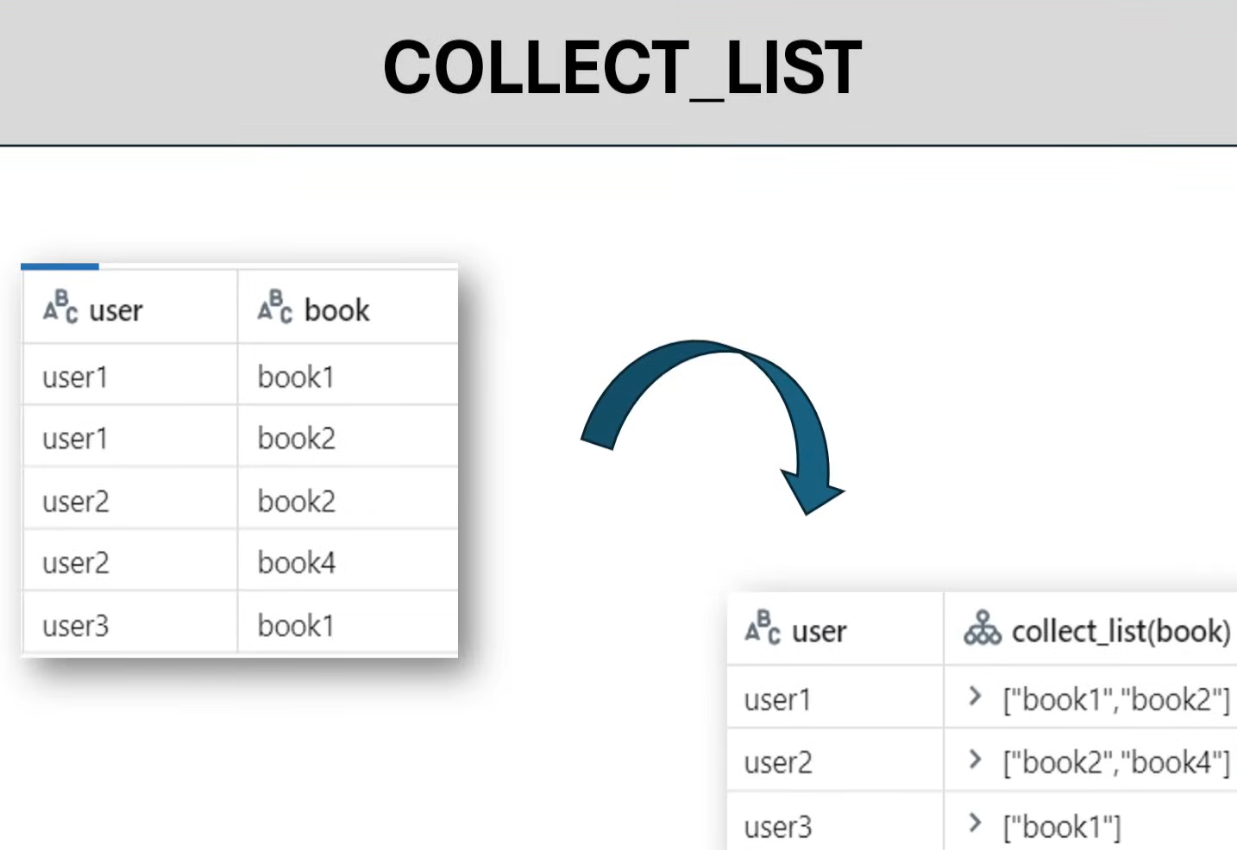
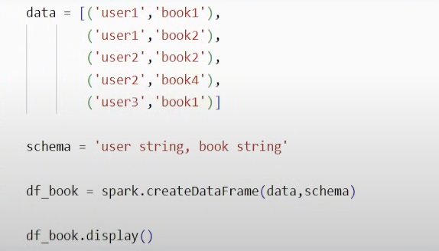
Df_book.groupby(‘user’).agg(collect_list(‘book’)).display()

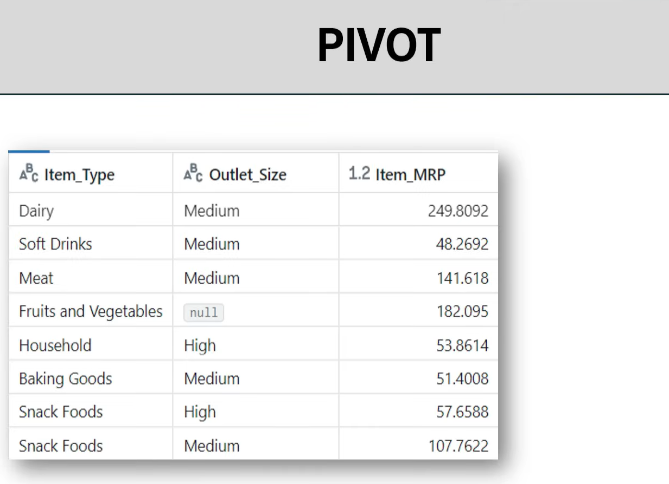
Df_book.groupby(‘Item_type’).pivot(‘Outlet_Size’).agg(avg(‘Item_MRP’)).display()
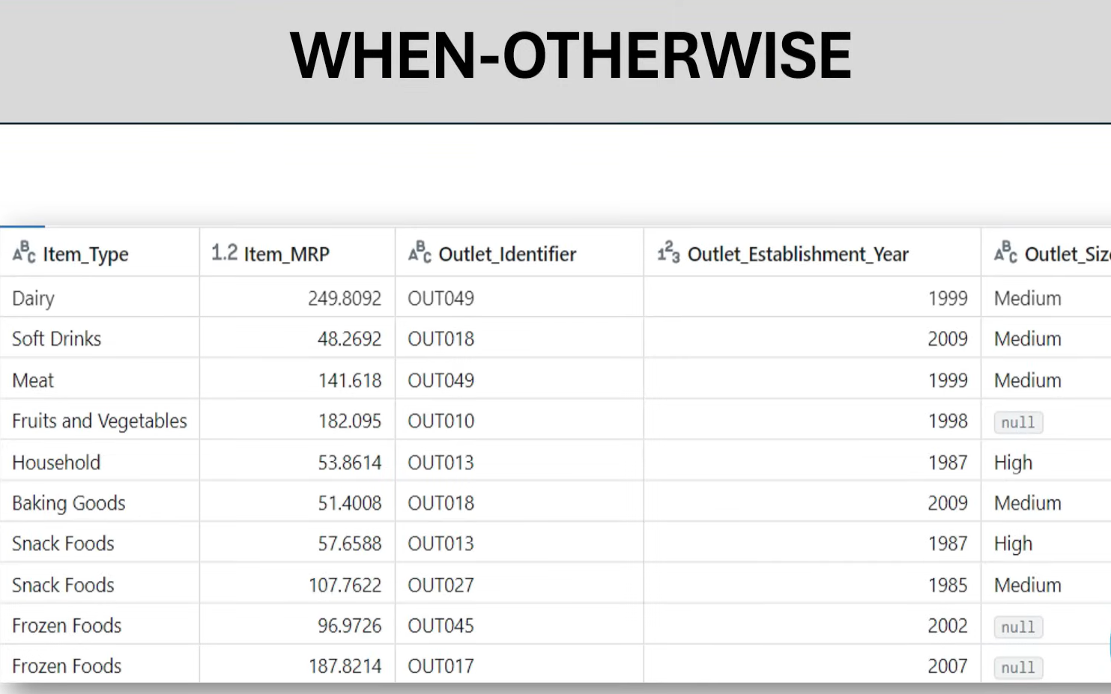
Df = Df.withcolumn(‘veg_flag’, when(col(‘Item_type’)==’Meat’,’Non-veg’).otherwise(‘Veg’)).display()
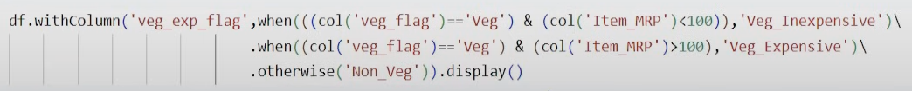

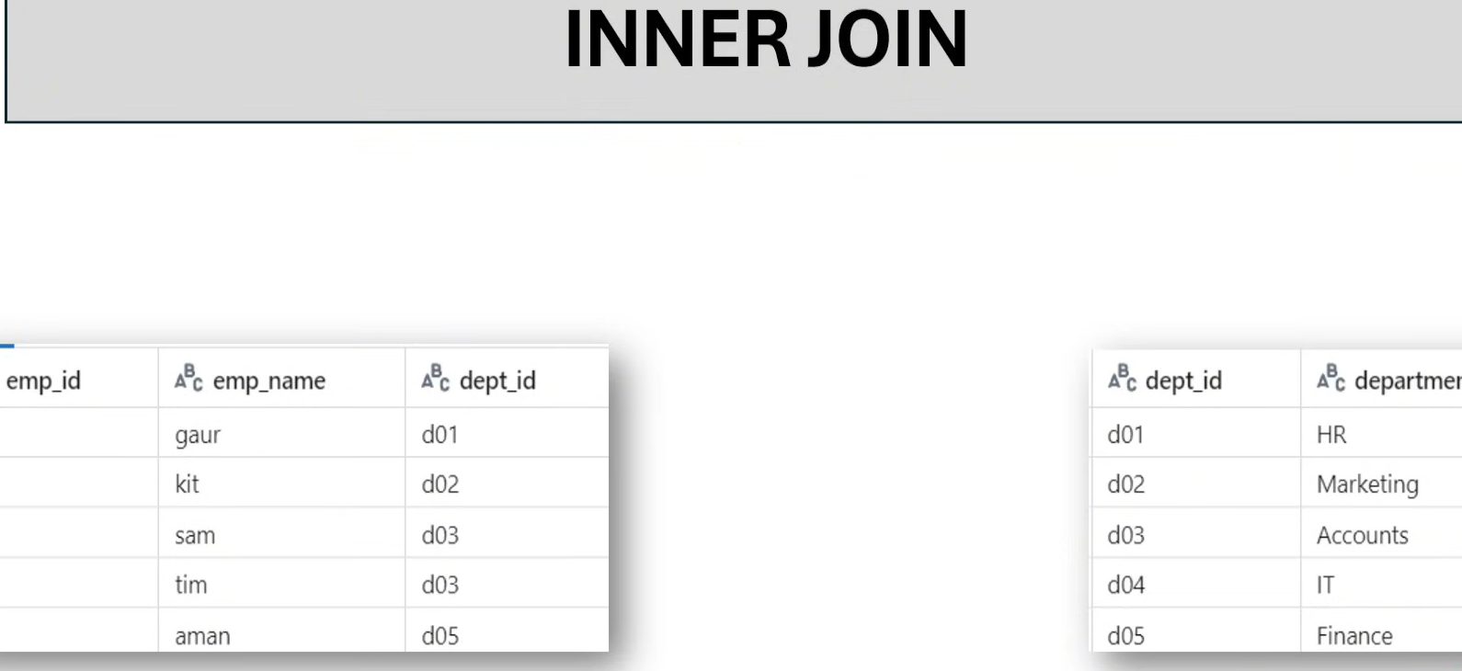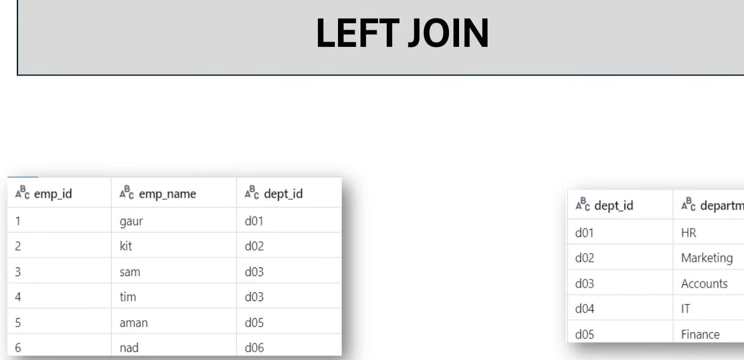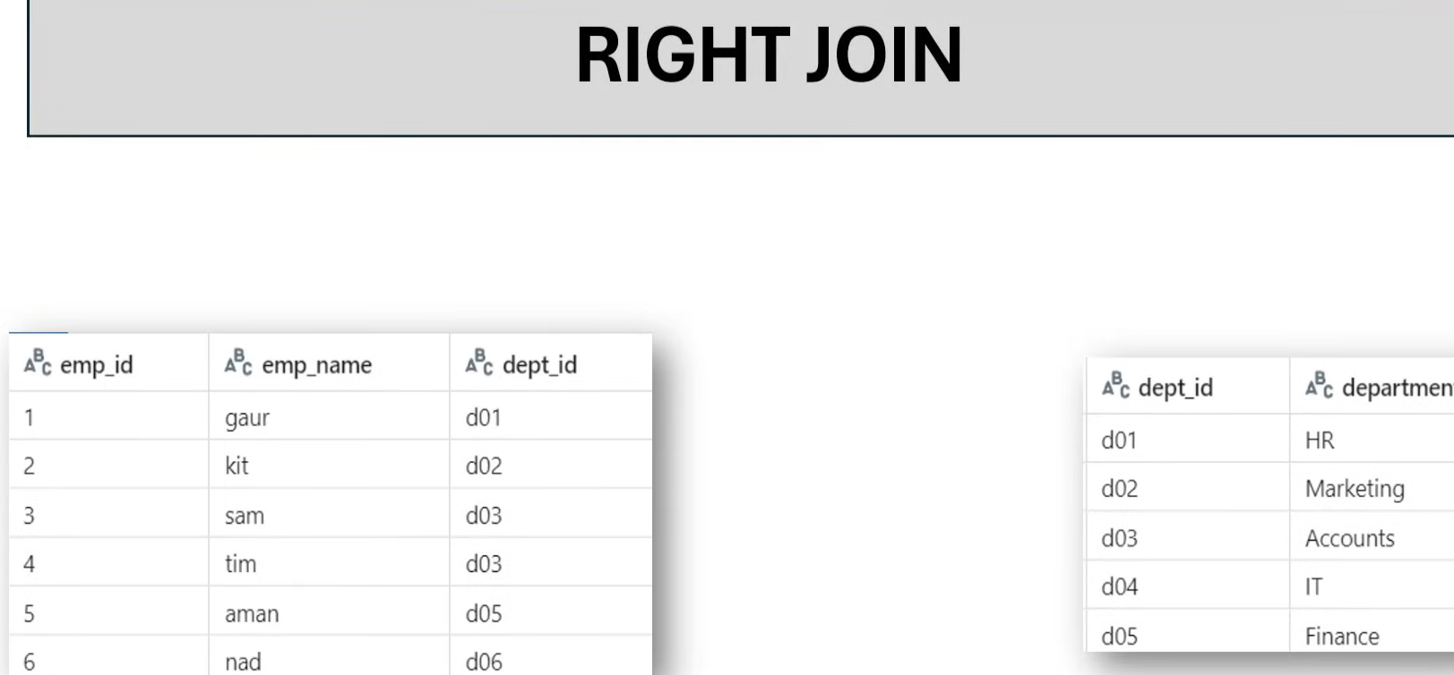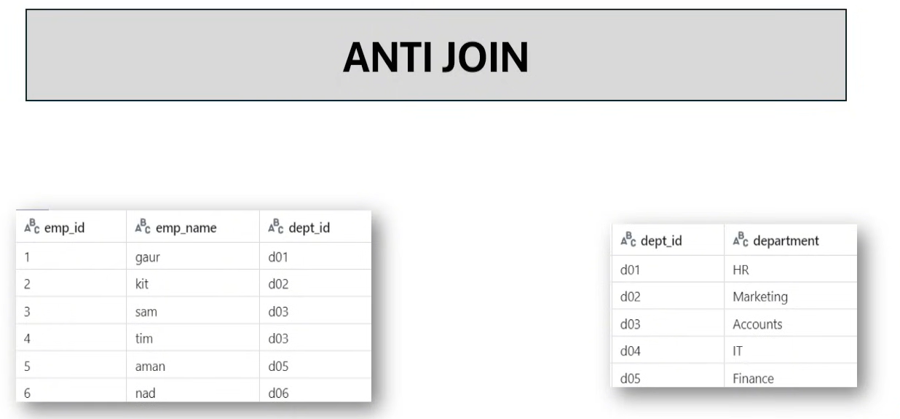
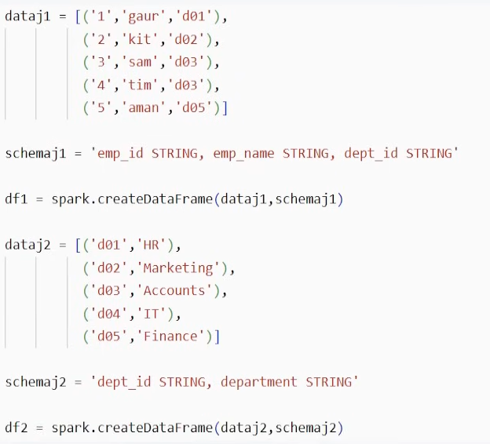
Df1.join(df2, df1[‘dept_id’]==df2[‘dept_id’],’inner’).display()

SQL JOIN
A JOIN clause is used to combine rows from two or more tables, based on a related column between them.
Let's look at a selection from the "Orders" table

OrderID | CustomerID | OrderDate
10308 | 2 | 1996-09-18
10309 | 37 | 1996-09-19
10310 | 77 | 1996-09-20

CustomerID | CustomerName | ContactName | Country
1 | Alfreds Futterkiste | Maria Anders | Germany
2 | Ana Trujillo Emparedados y helados | Ana Trujillo | Mexico
3 | Antonio Moreno Taquería | Antonio Moreno | Mexico
Then, look at a selection from the "Customers" table:
Notice that the "CustomerID" column in the "Orders" table refers to the "CustomerID" in the "Customers" table. The relationship between the two tables above is the "CustomerID" column.
Then, we can create the following SQL statement (that contains an INNER JOIN), that selects records that have matching values in both tables:
SELECT Orders.OrderID, Customers.CustomerName, Orders.OrderDate
FROM Orders
INNER JOIN Customers ON Orders.CustomerID=Customers.CustomerID;
and it will produce something like this:
OrderID | CustomerName | OrderDate
10308 | Ana Trujillo Emparedados y helados | 9/18/1996
10365 | Antonio Moreno Taquería | 11/27/1996
10383 | Around the Horn | 12/16/1996
10355 | Around the Horn | 11/15/1996
10278 | Berglunds snabbköp | 8/12/1996

Different Types of SQL JOINs
Here are the different types of the JOINs in SQL:
- (INNER) JOIN: Returns records that have matching values in both tables
- LEFT (OUTER) JOIN: Returns all records from the left table, and the matched records from the right table
- RIGHT (OUTER) JOIN: Returns all records from the right table, and the matched records from the left table
- FULL (OUTER) JOIN: Returns all records when there is a match in either left or right table
- 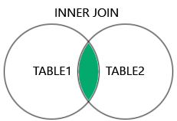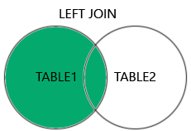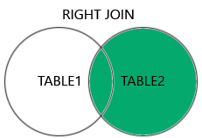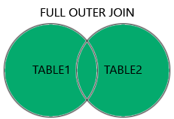

INNER JOIN
The INNER JOIN keyword selects records that have matching values in both tables.
Let's look at a selection of the Products table:

ProductID | ProductName | CategoryID | Price
1 | Chais | 1 | 18
2 | Chang | 1 | 19
3 | Aniseed Syrup | 2 | 10

And a selection of the Categories table:
CategoryID | CategoryName | Description
1 | Beverages | Soft drinks, coffees, teas, beers, and ales
2 | Condiments | Sweet and savory sauces, relishes, spreads, and seasonings
3 | Confections | Desserts, candies, and sweet breads

We will join the Products table with the Categories table, by using the CategoryID field from both tables:
SELECT ProductID, ProductName, CategoryName
FROM Products
INNER JOIN Categories ON Products.CategoryID = Categories.CategoryID;

Note: The INNER JOIN keyword returns only rows with a match in both tables. Which means that if you have a product with no CategoryID, or with a CategoryID that is not present in the Categories table, that record would not be returned in the result.

SQL LEFT JOIN Keyword
The LEFT JOIN keyword returns all records from the left table (table1), and the matching records from the right table (table2). The result is 0 records from the right side, if there is no match.

LEFT JOIN Syntax
SELECT column_name(s)
FROM table1
LEFT JOIN table2
ON table1.column_name = table2.column_name;
Note: In some databases LEFT JOIN is called LEFT OUTER JOIN.


Demo Database
In this tutorial we will use the well-known Northwind sample database.
Below is a selection from the "Customers" table:

CustomerID | CustomerName | ContactName | Address | City | PostalCode | Country
1 | Alfreds Futterkiste | Maria Anders | Obere Str. 57 | Berlin | 12209 | Germany
2 | Ana Trujillo Emparedados y helados | Ana Trujillo | Avda. de la Constitución 2222 | México D.F. | 05021 | Mexico
3 | Antonio Moreno Taquería | Antonio Moreno | Mataderos 2312 | México D.F. | 05023 | Mexico
And a selection from the "Orders" table:
OrderID | CustomerID | EmployeeID | OrderDate | ShipperID
10308 | 2 | 7 | 1996-09-18 | 3
10309 | 37 | 3 | 1996-09-19 | 1
10310 | 77 | 8 | 1996-09-20 | 2

SQL LEFT JOIN Example
The following SQL statement will select all customers, and any orders they might have:
SELECT Customers.CustomerName, Orders.OrderID
FROM Customers
LEFT JOIN Orders ON Customers.CustomerID = Orders.CustomerID
ORDER BY Customers.CustomerName;
Note: The LEFT JOIN keyword returns all records from the left table (Customers), even if there are no matches in the right table (Orders).

SQL RIGHT JOIN Keyword
The RIGHT JOIN keyword returns all records from the right table (table2), and the matching records from the left table (table1). The result is 0 records from the left side, if there is no match.

RIGHT JOIN Syntax
SELECT column_name(s)
FROM table1
RIGHT JOIN table2
ON table1.column_name = table2.column_name;
Note: In some databases RIGHT JOIN is called RIGHT OUTER JOIN.


Demo Database
In this tutorial we will use the well-known Northwind sample database.
Below is a selection from the "Orders" table:
OrderID | CustomerID | EmployeeID | OrderDate | ShipperID
10308 | 2 | 7 | 1996-09-18 | 3
10309 | 37 | 3 | 1996-09-19 | 1
10310 | 77 | 8 | 1996-09-20 | 2
And a selection from the "Employees" table:
EmployeeID | LastName | FirstName | BirthDate | Photo
1 | Davolio | Nancy | 12/8/1968 | EmpID1.pic
2 | Fuller | Andrew | 2/19/1952 | EmpID2.pic
3 | Leverling | Janet | 8/30/1963 | EmpID3.pic

SQL RIGHT JOIN Example
The following SQL statement will return all employees, and any orders they might have placed:
SELECT Orders.OrderID, Employees.LastName, Employees.FirstName
FROM Orders
RIGHT JOIN Employees ON Orders.EmployeeID = Employees.EmployeeID
ORDER BY Orders.OrderID;

Note: The RIGHT JOIN keyword returns all records from the right table (Employees), even if there are no matches in the left table (Orders).

SQL FULL OUTER JOIN Keyword
The FULL OUTER JOIN keyword returns all records when there is a match in left (table1) or right (table2) table records.
Tip: FULL OUTER JOIN and FULL JOIN are the same.

FULL OUTER JOIN Syntax
SELECT column_name(s)
FROM table1
FULL OUTER JOIN table2
ON table1.column_name = table2.column_name
WHERE condition;

Note: FULL OUTER JOIN can potentially return very large result-sets!

Demo Database
In this tutorial we will use the well-known Northwind sample database.
Below is a selection from the "Customers" table:
CustomerID | CustomerName | ContactName | Address | City | PostalCode | Country
1 | Alfreds Futterkiste | Maria Anders | Obere Str. 57 | Berlin | 12209 | Germany
2 | Ana Trujillo Emparedados y helados | Ana Trujillo | Avda. de la Constitución 2222 | México D.F. | 05021 | Mexico
3 | Antonio Moreno Taquería | Antonio Moreno | Mataderos 2312 | México D.F. | 05023 | Mexico
And a selection from the "Orders" table:
OrderID | CustomerID | EmployeeID | OrderDate | ShipperID
10308 | 2 | 7 | 1996-09-18 | 3
10309 | 37 | 3 | 1996-09-19 | 1
10310 | 77 | 8 | 1996-09-20 | 2

SQL FULL OUTER JOIN Example
The following SQL statement selects all customers, and all orders:

SELECT Customers.CustomerName, Orders.OrderID
FROM Customers
FULL OUTER JOIN Orders ON Customers.CustomerID=Orders.CustomerID
ORDER BY Customers.CustomerName;
A selection from the result set may look like this:
CustomerName | OrderID
Null | 10309
Null | 10310
Alfreds Futterkiste | Null
Ana Trujillo Emparedados y helados | 10308
Antonio Moreno Taquería | Null

Note: The FULL OUTER JOIN keyword returns all matching records from both tables whether the other table matches or not. So, if there are rows in "Customers" that do not have matches in "Orders", or if there are rows in "Orders" that do not have matches in "Customers", those rows will be listed as well.
INNER JOIN
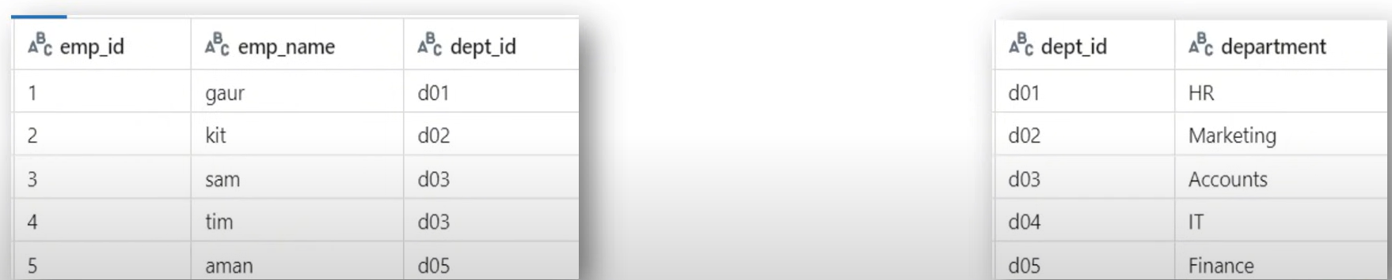
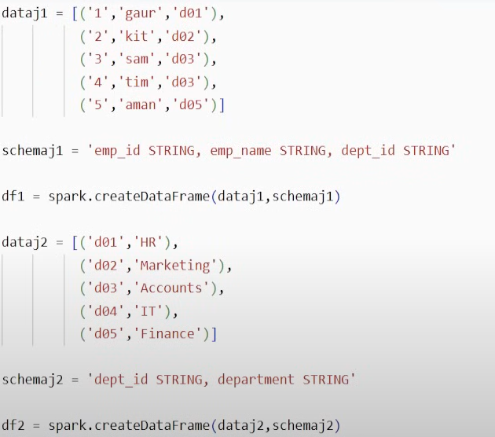
Df1.join(df2,df1[‘dept_id’]==df2[dept_id],’inner’).display()
LEFT JOIN
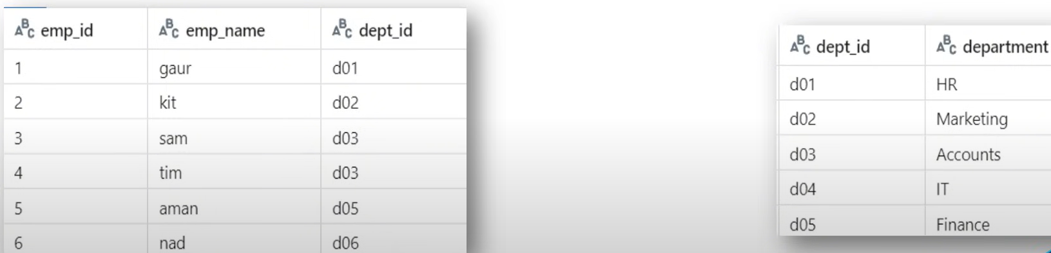
Df1.join(df2,df1[‘dept_id’]==df2[dept_id],’left’).display()

RIGHT JOIN
Df1.join(df2,df1[‘dept_id’]==df2[dept_id],’right’).display()

